Handy Hints for your Church

Could the place of worship encourage people to visit other attractions, (especially places of worship) nearby and directions of how to get there?
Is the place of worship proactive about encouraging schoolchildren and college
students to see the building and grounds as a place of study across many ,disciplines in the curriculum?
Could there be an information board that helps visitors find:

- petrol! diesel
- food
- accommodation
- vet
- doctor
- Chemist
- library
- transport -timetables and stopping places
- Citizens advice
- events in other places of worship and other venues
- could there be a map of the area to help visitors find the above?

Outside the Place of worship:
- Is it obvious that the church is open? - is there a sign saying the church is open?
- Is the entrance obvious and accessible?
- Are there any physical or other barriers to the entrance?
- Does the Notice Board give the information people want - does it welcome everybody - is it up to date?

Inside the Place of worship:
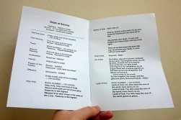
- Is the place welcoming? (flowers make a place warmer!)
- Is it well lit? trip switches can make economic sense.
- Is there a brief (and free!) leaflet for finding a way around?
- Does the leaflet include a brief message about Christianity?
- Is all literature clear and welcoming (inc the visually impaired)
- are there any aggressive Do Not ... notices?
- Is the literature accessible for everybody?
- Is there a token (a prayer card/bookmark) for people to take home to recall their visit to your church?
- Is it clear how a priest can be contacted?
- In how many languages is there a welcome sign?
- In how many languages is the literature for visitors?

Prayer: Is there a dedicated place for prayer with prayers available as an aid?
Is there a prayer request card system or book? - Could each place in the church be interpreted by a short passage about its function-
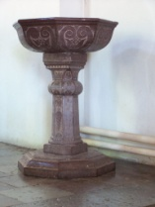
Eg. The Font : very short piece about any architectural worth - The font is used for Baptism - this font is made of Sutton Stone and is of Norman origin and a prayer at the font - for new life.

Quiet
Is there a request for people to keep quiet at certain times and/or in certain places?
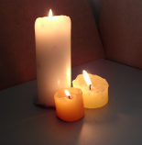
Human Interest
Can the various artifacts etc. be used to tell of people -the story of the community through the ages as well as any architectural worth?

Music
Any live music will almost always be appreciated - some places of worship use soft taped music to great effect.

Money
A contactless giving point is proving very useful in churches that have them. Ask for help in sourcing this digital aid! Is there a clear encouragement to make a donation - a box near the exit (regularly emptied) with a sign saying Thank You can be very effective?

Visitors Book
Very useful for estimating numbers attending the place of worship - a quality loose leaf binder enables pages to be removed in case Lord Lucan / Elvis /Mickey Mouse visit or even unwanted language! These days ensure you collect email addresses. Remember that an email address will mean you can contact your visitors at Christmas and Easter etc or to advertise special services and major events that might be invitation to them to come back and visit.

Genealogy
Are church records available - in digital format?
Could the inscriptions on the gravestones be transcribed and logged on a plan?

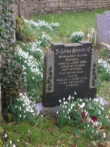
Churchyard
Could any of the grounds be developed ecologically?
Could the various plants, bushes and trees be identified on a plan and displayed? Do you need to speak to Caring for God’s Acre?

Not everything suggested will be right for your church but it is worth you (and the PCC or Church council) having a look at the suggestions and improving your welcome to visitors as a result.
www.discover shropshirechurches.co.uk

